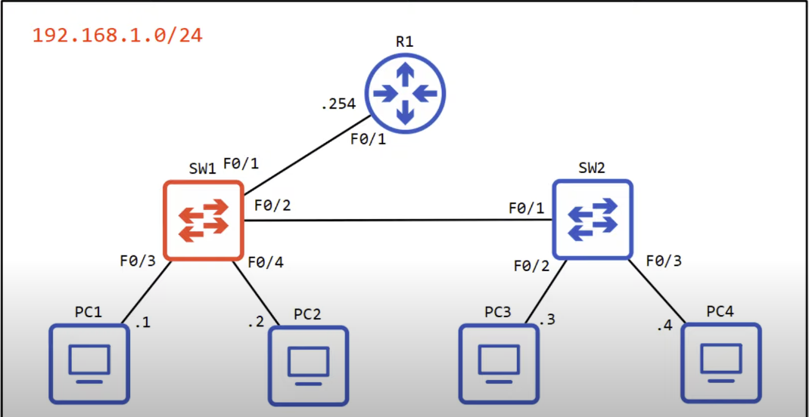

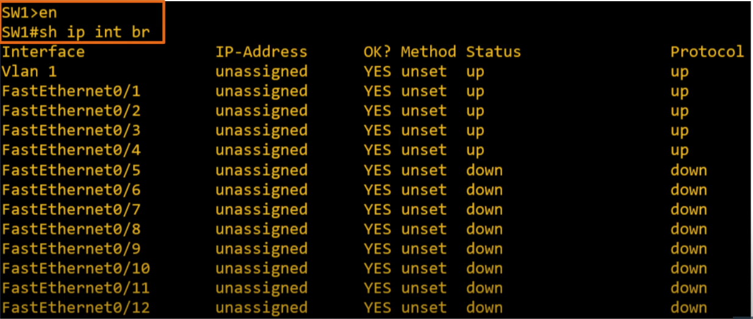
Network Topology

CLI of SW1
Note:Router interfaces are in administratively disabled Status by default,meaning they have the ‘shutdown’ command applied.Switch interfaces are different,they don’t have shutdown command applied,so if we connect them to another device they’ll usually be in up/up(Protocol and Status are up) state with no configuration required.
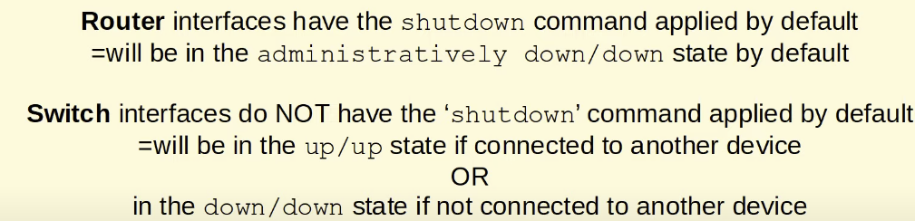
Note:The IP address is unassigned,and it will remain that way,because these are Layer 2 switchports,they don’t need an IP address.However there is concept of multilayer switching,where we do assign IP addresses to switches.
Note:

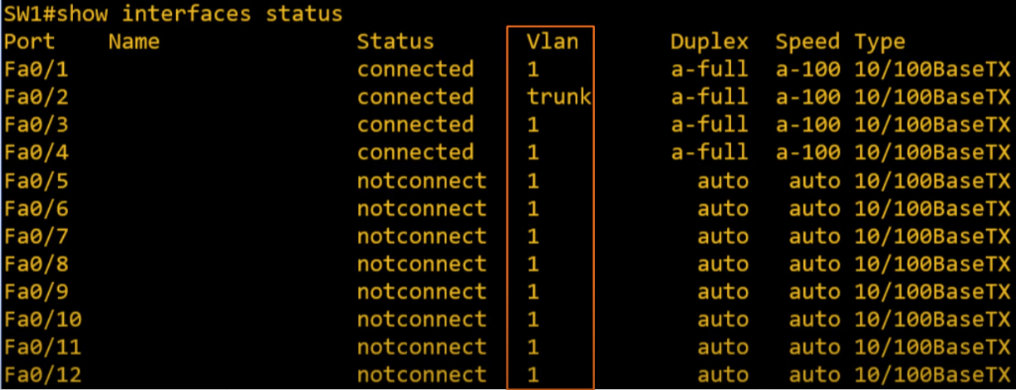

‘show interfaces status’ command in SW1 CLI
Name field is the description of the interface.
Duplex field indicates whether the device is capable of both sending and receiving data at the same time,which is known as full-duplex,or if its not,which is called half-duplex.Duplex is auto by default on Cisco switches,meaning it will negotiate with the neighboring device and use full-duplex if possible.’a-full’(auto-full) means that it automatically negotiated a Duplex of full with the neighboring device.
Speed field is also ‘auto’ by default.These are fast ethernet interfaces,so they are capable of speeds up 100 megabits per second.’auto’ means they are able to negotiate with the device they are connected to and use fastest speed both devices are capable of.’a-100’ means a speed of 100 megabits per second is auto-negotiated with the neighboring device.

Type field In example these are all RJ-45 interfaces for copper utp cables,but if they were SFP modules we’d see that here instead.We see 10/100BASE-TX,the ‘10/100’ refers to the speeds at which these interfaces operate.
Note:Vlan of Fa0/2 is connected to switch and it’s vlan is trunk interface,in difference to others,which are connected to PCs.

Configuring switch f0/1 network interface speed and duplex
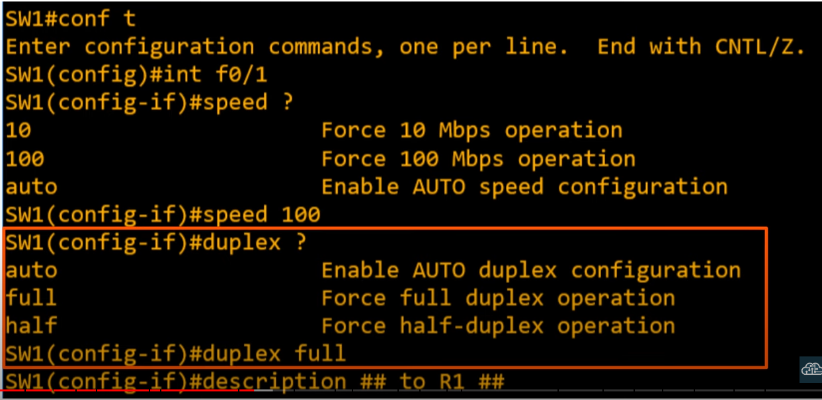

‘speed’ command is for configuring the speed of the interface.We set the speed to 100 R1’s interface is a fastethernet interface(100 Mbit/s) also.
‘duplex’ command allows to set the duplex of the interface.Both SW1 and R1 support full-duplex so we choose ‘full’.
Finally we configure the description of the interface.
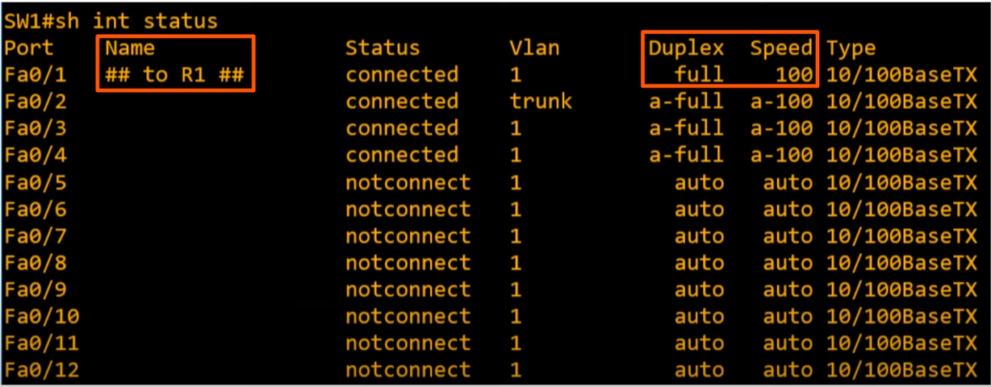
After running ‘show interface status’ command

speed and duplex became 100 and full,instead of a-full and a-100 because they are not being autonegotiated anymore`.But normally we will set autonegotiaton on,but if there is a problem and its not working we can manually speed and duplex configure it.
Note: This command does not work on routers.
Note: Although the fact that switch interfaces are enabled by defualt is convenient we should disable them for security as we can just plug a device in and use it straight away,it can be a security concern.Really, we should disable the interfaces.

‘interface range’ command
Instead of configuring each interface ony by one,there is a way to configure all interfaces at once
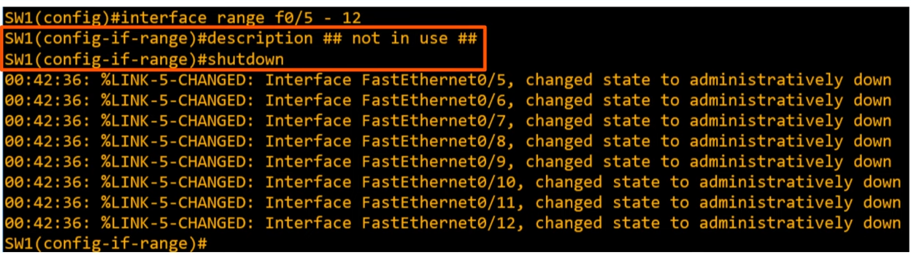
‘interface range’ command in use

When we run ‘interface range <interfacename_slotname/first_port – last_port>’ instead of entering interface config mode,it enters interface range config mode.And we enter a description and shutdown all interfaces.
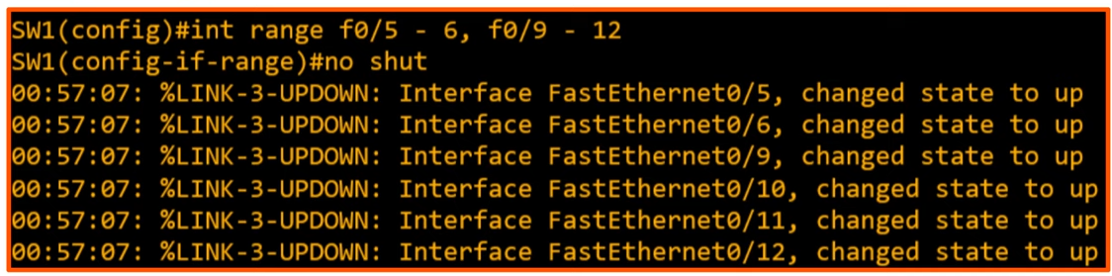
‘interface range’ cool thing with no consecutive interfaces.(enabling the disabled interfaces)
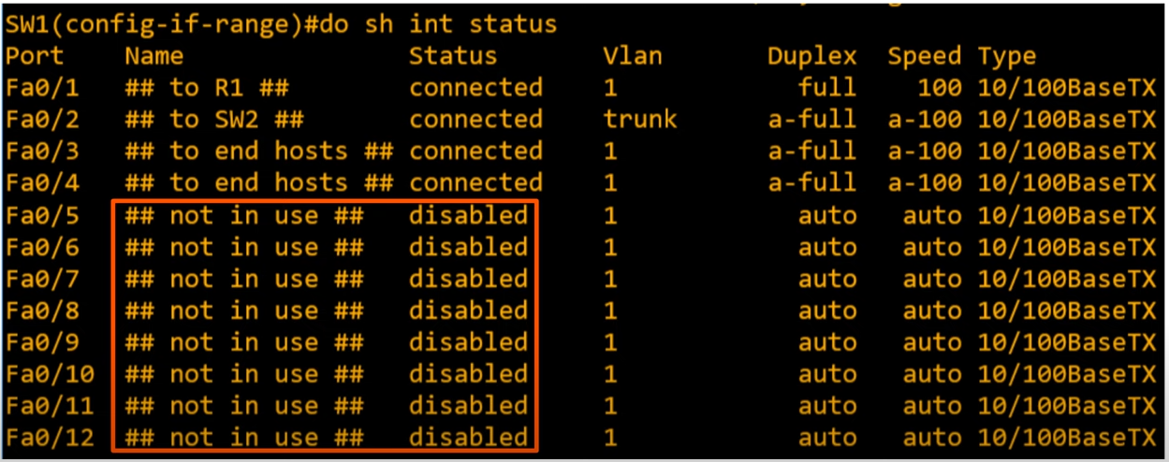
After disabling interfaces with ‘interface range’ command
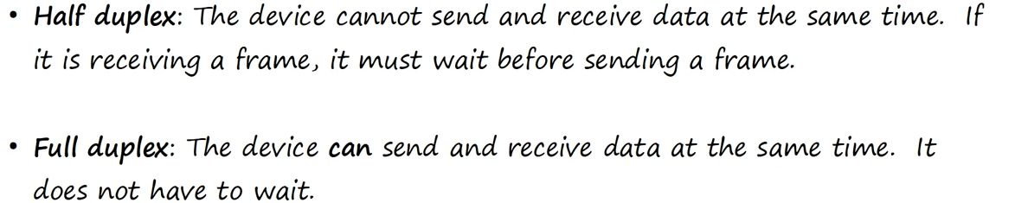
Half and Full Duplex

Lan Hub(network device)(for understanding where half-duplex is used)
Lan hub is an old network device,that was around before the network switch.In fact it is simply a repeater.Any frame it receives,it floods,like a switch does with a broadcast or unknown unicast frame.
Note:Lan hubs Are simple repeaters which operate at Layer1,repeating whatever signal they receive,but switches operate at Layer 2 using MAC addressing.

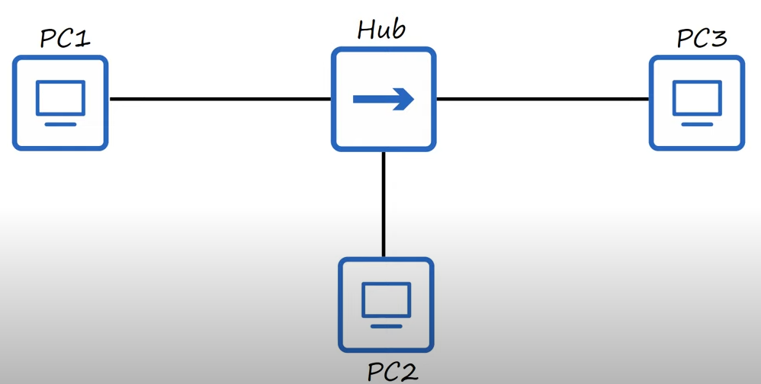
Note: In a situation when PC1 and PC3 try to send a frame(P1 sends frame to PC2,and PC3 sends a frame to PC1) at the same time.The Hub won’t sent one frame first and the other after,it will try to flood both at the same time,and it will result in a collision in the interface.And PC2 won’t receive either frame intact.All devices connected to a Hub are part of collision domain. The frames they send could collide with frames any of other devices connected to the Hub send.To deal with collisions in a half duplex situations like this we ethernet devices use CSMA/CD.
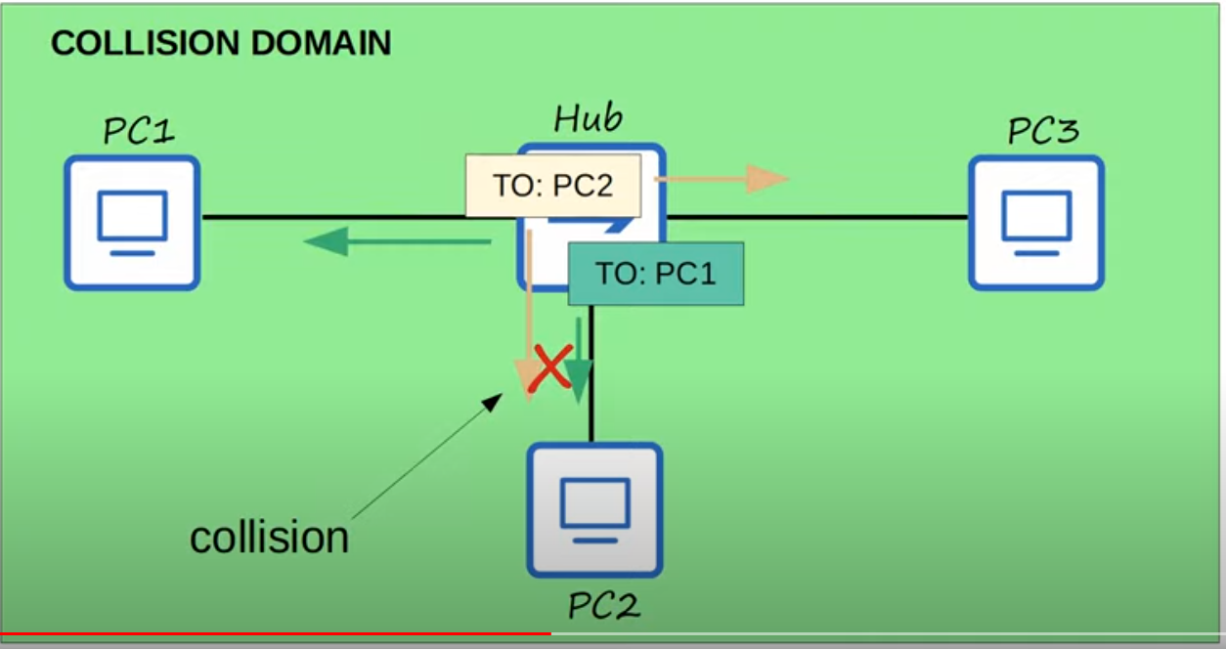

CSMA/CD
CSMA/CD describes how devices avoid collisions in a half-duplex situations,and how they react if collisions occur.
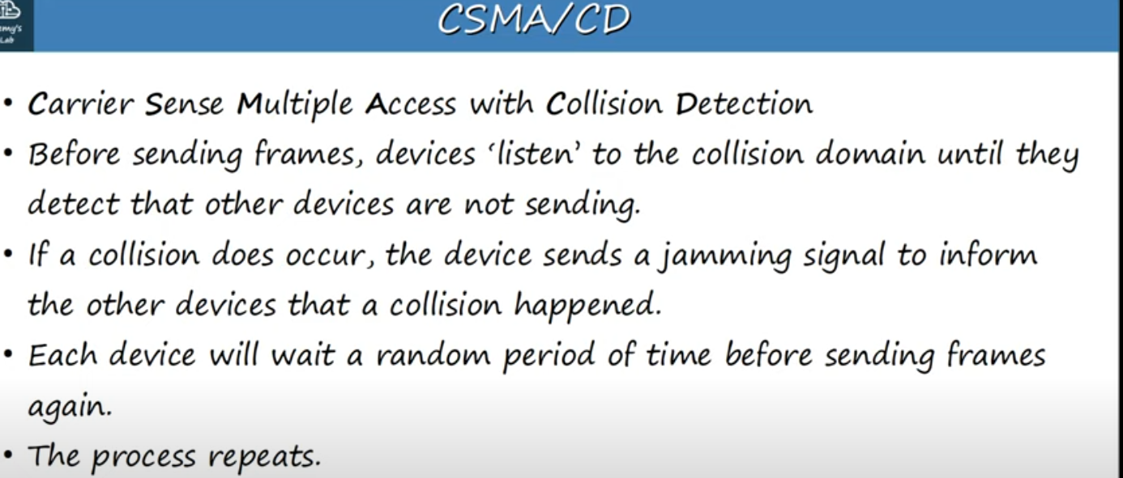

CSMA/CD

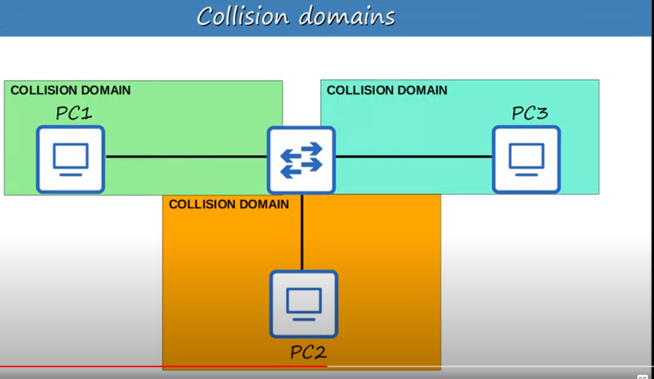

When we change hub with switch,this network,which was one collision domain,is now 3 collision domains.Because of the improved functionality of switches over hubs,these devices can operate in full-duplex,meaning they don’t have to worry about whether or not other devices are sending data at the same time or not,they can send data freely(without waiting).Although collisions can still occur,,they are rare and usually a sign of misconfiguration,rather than a regular occurrence.
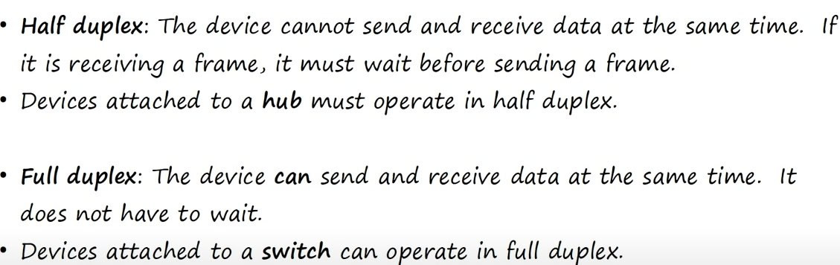

Half and Full duplex review
Note: In modern networks we usually don’t use hubs.

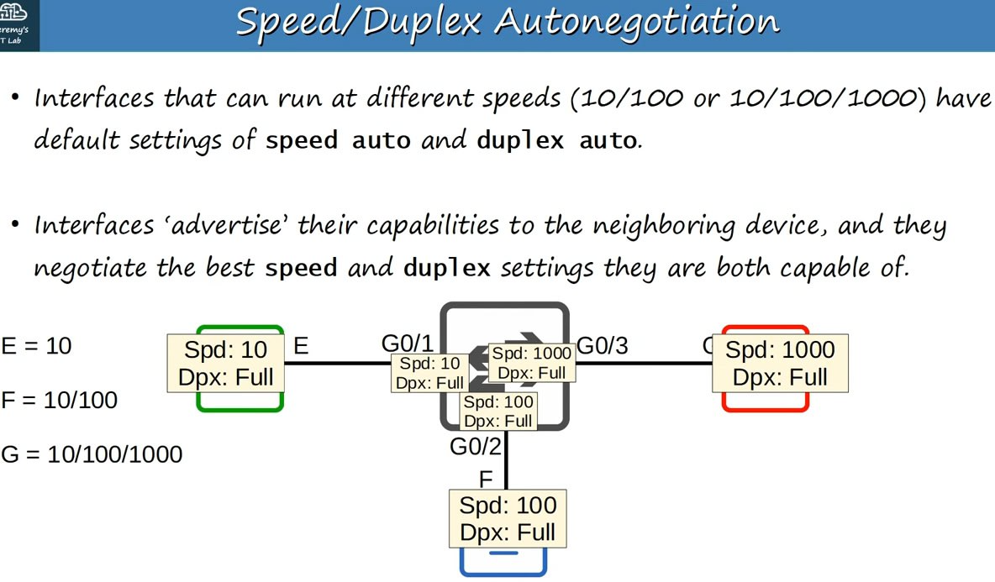
Speed/Duplex Autonegotiation(results of autonegotiation)

E,F,G Ethernet,FastEthernet,GigabitEthernet interfaces of PC’s.
Note: This applies both to routers and switches.
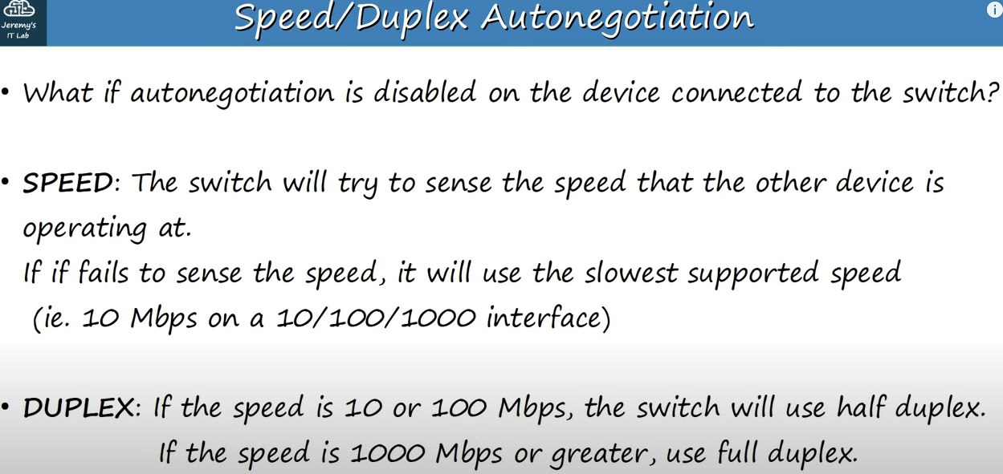

If autonegotiation is disabled on the device that is connected to switch
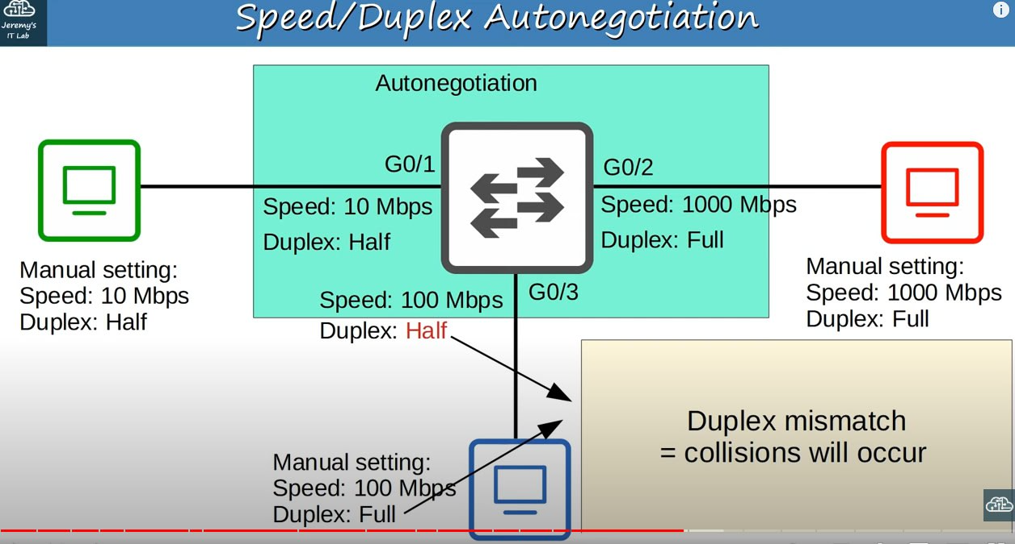

Results,if autonegotiation is enabled only on switch
Note:Duplex mismatch results in poor network.So we should use autonegotiation on all devices.
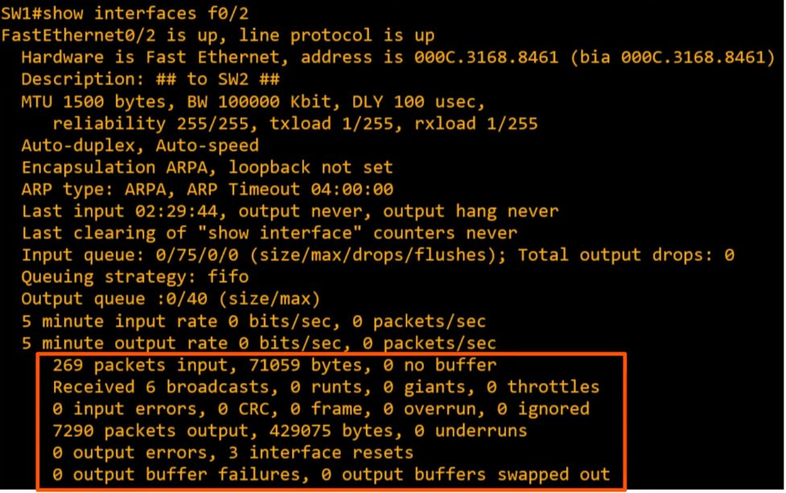

Output of ‘show interfaces’ command
Note: Bottom part displays Interface counters and errors

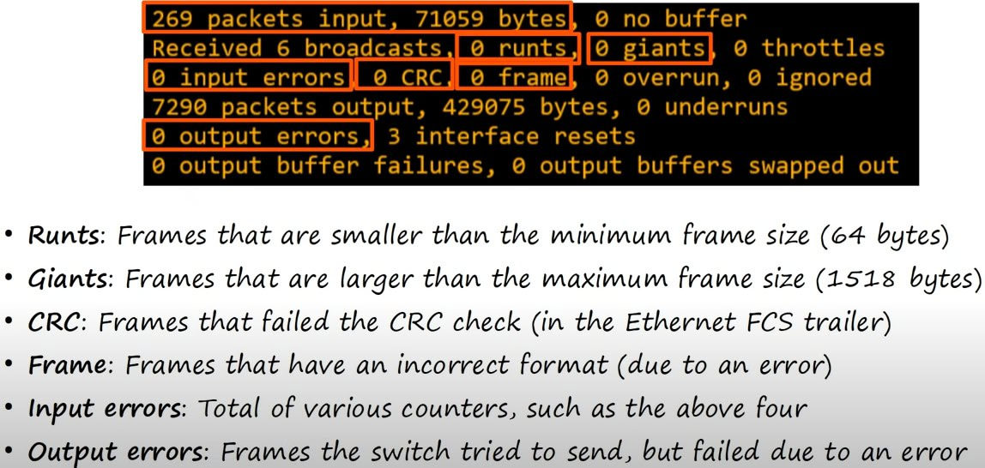

Explanation of bottom part statistics
Note: 269 packets are received with total 71059 bytes in those packets.
Note: This both applies to routers and switches
Note: CRC = Cyclic redundancy check.CRC is done via FCS.
Note: Input errors include those four above it.

From lab 9
Note:Devices attached to Switch can use full duplex.There is no need to use half-duplex like a device attached to hub.

